

Data Structures

Semester Project – Car Rental management system
Subject Code: COC2074L
Submitted To: Sir Abdul Basit
Section: BSCS-B (3rd)
Date of Submission: 8-Jan-2026
Submitted By

NAME | REG. NO.
Mujtaba Sohail | 24-NTU-CS-FL-1076
Muzammil Abbas | 24-NTU-CS-FL-1082

Code
#include <iostream>
#include <string>
#include <sstream>
#include <iomanip>
#include <fstream>
#include <cstdlib>
using namespace std;

struct CarNode {
int id;
string brand;
string model;
bool available;
CarNode* left;
CarNode* right;

CarNode(int i, string b, string m, bool a = true) {
id = i;
brand = b;
model = m;
available = a;
left = right = NULL;
}
};

struct CustomerNode {
int id;
string name;
string phone;
CustomerNode* left;
CustomerNode* right;

CustomerNode(int i, string n, string p) {
id = i;
name = n;
phone = p;
left = right = NULL;
}
};

struct QueueNode {
int requestId;
int carId;
int customerId;
double cost;
string date;
QueueNode* next;

QueueNode(int r, int c, int cu, double co, string d) {
requestId = r;
carId = c;
customerId = cu;
cost = co;
date = d;
next = NULL;
}
};

struct StackNode {
string description;
double amount;
string date;
StackNode* next;

StackNode(string d, double a, string da) {
description = d;
amount = a;
date = da;
next = NULL;
}
};

class CarBST {
CarNode* root;

CarNode* insert(CarNode* r, CarNode* n) {
if (!r) return n;
if (n->id < r->id)
r->left = insert(r->left, n);
else
r->right = insert(r->right, n);
return r;
}

void inorder(CarNode* r) {
if (!r) return;
inorder(r->left);
cout << " | " << setw(6) << r->id << " | "
<< setw(12) << r->brand << " | "
<< setw(12) << r->model << " | "
<< setw(10) << (r->available ? "Available" : "Rented") << " |\n";
inorder(r->right);
}

void saveToFile(CarNode* r, ofstream& file) {
if (!r) return;
saveToFile(r->left, file);
file << r->id << "," << r->brand << "," << r->model << "," << r->available << endl;
saveToFile(r->right, file);
}

public:
CarBST() {
root = NULL;
}

void addCar(int id, string b, string m, bool a = true) {
root = insert(root, new CarNode(id, b, m, a));
}

CarNode* find(int id) {
CarNode* t = root;
while (t) {
if (t->id == id) return t;
if (id < t->id) t = t->left;
else t = t->right;
}
return NULL;
}

CarNode* deleteNode(CarNode* r, int id) {
if (!r) return NULL;
if (id < r->id)
r->left = deleteNode(r->left, id);
else if (id > r->id)
r->right = deleteNode(r->right, id);
else {
if (!r->left) {
CarNode* temp = r->right;
delete r;
return temp;
} else if (!r->right) {
CarNode* temp = r->left;
delete r;
return temp;
}
CarNode* temp = r->right;
while (temp->left) temp = temp->left;
r->id = temp->id;
r->brand = temp->brand;
r->model = temp->model;
r->available = temp->available;
r->right = deleteNode(r->right, temp->id);
}
return r;
}

bool updateCar(int id, string b, string m, bool a) {
CarNode* car = find(id);
if (car) {
car->brand = b;
car->model = m;
car->available = a;
return true;
}
return false;
}

bool deleteCar(int id) {
if (find(id)) {
root = deleteNode(root, id);
return true;
}
return false;
}

void display() {
if (!root) {
cout << "\n +----------------------------------------------------+\n";
cout << " | No cars available in system. |\n";
cout << " +----------------------------------------------------+\n";
return;
}
cout << "\n +--------+--------------+--------------+------------+\n";
cout << " | Car ID | Brand | Model | Status |\n";
cout << " +--------+--------------+--------------+------------+\n";
inorder(root);
cout << " +--------+--------------+--------------+------------+\n";
}

void saveToFile() {
ofstream file("cars.csv");
if (file.is_open()) {
file << "ID,Brand,Model,Available\n";
saveToFile(root, file);
file.close();
}
}

void loadFromFile() {
ifstream file("cars.csv");
if (file.is_open()) {
string line;
bool firstLine = true;
while (getline(file, line)) {
if (firstLine) {
firstLine = false;
continue;
}
if (line.empty()) continue;
stringstream ss(line);
string id_str, brand, model, avail_str;

getline(ss, id_str, ',');
getline(ss, brand, ',');
getline(ss, model, ',');
getline(ss, avail_str, ',');

int id = atoi(id_str.c_str());
bool available = (avail_str == "1" || avail_str == "true" || avail_str == "True");

addCar(id, brand, model, available);
}
file.close();
}
}
};

class CustomerBST {
CustomerNode* root;

CustomerNode* insert(CustomerNode* r, CustomerNode* n) {
if (!r) return n;
if (n->id < r->id)
r->left = insert(r->left, n);
else
r->right = insert(r->right, n);
return r;
}

void inorder(CustomerNode* r) {
if (!r) return;
inorder(r->left);
cout << " | " << setw(7) << r->id << " | "
<< setw(20) << r->name << " | "
<< setw(15) << r->phone << " |\n";
inorder(r->right);
}

void saveToFile(CustomerNode* r, ofstream& file) {
if (!r) return;
saveToFile(r->left, file);
file << r->id << "," << r->name << "," << r->phone << endl;
saveToFile(r->right, file);
}

public:
CustomerBST() {
root = NULL;
}

void addCustomer(int id, string n, string p) {
root = insert(root, new CustomerNode(id, n, p));
}

CustomerNode* find(int id) {
CustomerNode* t = root;
while (t) {
if (t->id == id) return t;
if (id < t->id) t = t->left;
else t = t->right;
}
return NULL;
}

CustomerNode* deleteNode(CustomerNode* r, int id) {
if (!r) return NULL;
if (id < r->id)
r->left = deleteNode(r->left, id);
else if (id > r->id)
r->right = deleteNode(r->right, id);
else {
if (!r->left) {
CustomerNode* temp = r->right;
delete r;
return temp;
} else if (!r->right) {
CustomerNode* temp = r->left;
delete r;
return temp;
}
CustomerNode* temp = r->right;
while (temp->left) temp = temp->left;
r->id = temp->id;
r->name = temp->name;
r->phone = temp->phone;
r->right = deleteNode(r->right, temp->id);
}
return r;
}

bool updateCustomer(int id, string n, string p) {
CustomerNode* customer = find(id);
if (customer) {
customer->name = n;
customer->phone = p;
return true;
}
return false;
}

bool deleteCustomer(int id) {
if (find(id)) {
root = deleteNode(root, id);
return true;
}
return false;
}

void display() {
if (!root) {
cout << "\n +----------------------------------------------------+\n";
cout << " | No customers registered in system. |\n";
cout << " +----------------------------------------------------+\n";
return;
}
cout << "\n +---------+----------------------+-----------------+\n";
cout << " | Cust ID | Name | Phone |\n";
cout << " +---------+----------------------+-----------------+\n";
inorder(root);
cout << " +---------+----------------------+-----------------+\n";
}

void saveToFile() {
ofstream file("customers.csv");
if (file.is_open()) {
file << "ID,Name,Phone\n";
saveToFile(root, file);
file.close();
}
}

void loadFromFile() {
ifstream file("customers.csv");
if (file.is_open()) {
string line;
bool firstLine = true;
while (getline(file, line)) {
if (firstLine) {
firstLine = false;
continue;
}
if (line.empty()) continue;
stringstream ss(line);
string id_str, name, phone;

getline(ss, id_str, ',');
getline(ss, name, ',');
getline(ss, phone, ',');

int id = atoi(id_str.c_str());

addCustomer(id, name, phone);
}
file.close();
}
}
};

class Queue {
QueueNode* front;
QueueNode* rear;

public:
Queue() {
front = rear = NULL;
}

void enqueue(int r, int c, int cu, double cost, string d) {
QueueNode* n = new QueueNode(r, c, cu, cost, d);
if (!rear)
front = rear = n;
else {
rear->next = n;
rear = n;
}
}

QueueNode* peek() {
return front;
}

void dequeue() {
if (!front) return;
QueueNode* t = front;
front = front->next;
if (!front) rear = NULL;
delete t;
}

bool empty() {
return front == NULL;
}

void display(string type) {
if (!front) {
cout << "\n +----------------------------------------------------+\n";
cout << " | No pending " << type << " requests. |\n";
cout << " +----------------------------------------------------+\n";
return;
}
cout << "\n +--------+--------+----------+----------+------------+\n";
cout << " | Req ID | Car ID | Cust ID | Cost | Date |\n";
cout << " +--------+--------+----------+----------+------------+\n";
QueueNode* t = front;
while (t) {
cout << " | " << setw(6) << t->requestId << " | "
<< setw(6) << t->carId << " | "
<< setw(8) << t->customerId << " | $"
<< setw(7) << fixed << setprecision(2) << t->cost << " | "
<< setw(10) << t->date << " |\n";
t = t->next;
}
cout << " +--------+--------+----------+----------+------------+\n";
}

void saveToFile(string filename) {
ofstream file(filename.c_str());
if (file.is_open()) {
file << "RequestID,CarID,CustomerID,Cost,Date\n";
QueueNode* t = front;
while (t) {
file << t->requestId << "," << t->carId << "," << t->customerId
<< "," << fixed << setprecision(2) << t->cost << "," << t->date << endl;
t = t->next;
}
file.close();
}
}

void loadFromFile(string filename) {
ifstream file(filename.c_str());
if (file.is_open()) {
string line;
bool firstLine = true;
while (getline(file, line)) {
if (firstLine) {
firstLine = false;
continue;
}
if (line.empty()) continue;
stringstream ss(line);
string req_str, car_str, cust_str, cost_str, date;

getline(ss, req_str, ',');
getline(ss, car_str, ',');
getline(ss, cust_str, ',');
getline(ss, cost_str, ',');
getline(ss, date, ',');

int reqId = atoi(req_str.c_str());
int carId = atoi(car_str.c_str());
int custId = atoi(cust_str.c_str());
double cost = atof(cost_str.c_str());

enqueue(reqId, carId, custId, cost, date);
}
file.close();
}
}
};

class Stack {
StackNode* top;

public:
Stack() {
top = NULL;
}

void push(string d, double a, string da) {
StackNode* n = new StackNode(d, a, da);
n->next = top;
top = n;
}

void display(string title) {
if (!top) {
cout << "\n +----------------------------------------------------+\n";
cout << " | No " << title << " records available. |\n";
cout << " +----------------------------------------------------+\n";
return;
}
cout << "\n +------------+--------------------------+------------+\n";
cout << " | Date | Description | Amount |\n";
cout << " +------------+--------------------------+------------+\n";
StackNode* t = top;
double total = 0;
while (t) {
cout << " | " << setw(10) << t->date << " | "
<< setw(24) << t->description << " | $"
<< setw(9) << fixed << setprecision(2) << t->amount << " |\n";
total += t->amount;
t = t->next;
}
cout << " +------------+--------------------------+------------+\n";
cout << " | TOTAL AMOUNT | $"
<< setw(9) << fixed << setprecision(2) << total << " |\n";
cout << " +-------------------------------------------+------------+\n";
}

void saveToFile(string filename) {
ofstream file(filename.c_str());
if (file.is_open()) {
file << "Description,Amount,Date\n";
StackNode* t = top;
while (t) {
file << t->description << "," << fixed << setprecision(2) << t->amount << "," << t->date << endl;
t = t->next;
}
file.close();
}
}

void loadFromFile(string filename) {
ifstream file(filename.c_str());
if (file.is_open()) {
string line;
bool firstLine = true;
while (getline(file, line)) {
if (firstLine) {
firstLine = false;
continue;
}
if (line.empty()) continue;
stringstream ss(line);
string desc, amount_str, date;

getline(ss, desc, ',');
getline(ss, amount_str, ',');
getline(ss, date, ',');

double amount = atof(amount_str.c_str());

push(desc, amount, date);
}
file.close();
}
}
};

class CarWorkshopRentalSystem {
CarBST cars;
CustomerBST customers;
Queue rentalQueue;
Queue serviceQueue;
Stack maintenance;
Stack revenue;

int carId;
int custId;
int reqId;

void saveCounters() {
ofstream file("counters.csv");
if (file.is_open()) {
file << "CarID,CustomerID,RequestID\n";
file << carId << "," << custId << "," << reqId << endl;
file.close();
}
}

void loadCounters() {
ifstream file("counters.csv");
if (file.is_open()) {
string line;
bool firstLine = true;
while (getline(file, line)) {
if (firstLine) {
firstLine = false;
continue;
}
if (line.empty()) continue;
stringstream ss(line);
string car_str, cust_str, req_str;

getline(ss, car_str, ',');
getline(ss, cust_str, ',');
getline(ss, req_str, ',');

carId = atoi(car_str.c_str());
custId = atoi(cust_str.c_str());
reqId = atoi(req_str.c_str());
}
file.close();
}
}

public:
CarWorkshopRentalSystem() {
carId = 100;
custId = 500;
reqId = 1;

// Load all data from files
loadCounters();
cars.loadFromFile();
customers.loadFromFile();
rentalQueue.loadFromFile("rentals.csv");
serviceQueue.loadFromFile("services.csv");
maintenance.loadFromFile("maintenance.csv");
revenue.loadFromFile("revenue.csv");
}

~CarWorkshopRentalSystem() {
// Save all data to files when program exits
saveAllData();
}

void saveAllData() {
saveCounters();
cars.saveToFile();
customers.saveToFile();
rentalQueue.saveToFile("rentals.csv");
serviceQueue.saveToFile("services.csv");
maintenance.saveToFile("maintenance.csv");
revenue.saveToFile("revenue.csv");
}

void clearScreen() {
#ifdef _WIN32
system("cls");
#else
system("clear");
#endif
}

void header(string t) {
cout << "\n+=========================================================+\n";
cout << "| " << setw(55) << t << " |\n";
cout << "+=========================================================+\n";
}

void pause() {
cout << "\n Press Enter to continue...";
cin.ignore();
cin.get();
}

void successMessage(string msg) {
cout << "\n >> SUCCESS: " << msg << "\n";
}

void errorMessage(string msg) {
cout << "\n >> ERROR: " << msg << "\n";
}

void addCar() {
string b, m;
header("ADD NEW CAR TO FLEET");
cout << "\n Enter car details below:\n";
cout << " -----------------------------------------\n";
cout << " Car Brand (e.g., Toyota, Honda) : ";
cin >> b;
cout << " Car Model (e.g., Corolla, Civic) : ";
cin >> m;

cars.addCar(carId, b, m);
cout << "\n >> SUCCESS: Car added successfully! (Car ID: " << carId << ")\n";
carId++;
saveAllData();
pause();
}

void addCustomer() {
string n, p;
header("REGISTER NEW CUSTOMER");
cin.ignore();
cout << "\n Enter customer details below:\n";
cout << " -----------------------------------------\n";
cout << " Full Name : ";
getline(cin, n);
cout << " Phone Number : ";
cin >> p;

customers.addCustomer(custId, n, p);
cout << "\n >> SUCCESS: Customer registered successfully! (Customer ID: " << custId << ")\n";
custId++;
saveAllData();
pause();
}

void updateCar() {
int id;
string b, m;
int avail_choice;
header("UPDATE CAR INFORMATION");

cout << "\n First, view all cars:\n";
cars.display();

cout << "\n Enter Car ID to update: ";
cin >> id;

CarNode* car = cars.find(id);
if (!car) {
errorMessage("Car ID not found!");
pause();
return;
}

cout << "\n Current Car Details:\n";
cout << " Brand: " << car->brand << "\n";
cout << " Model: " << car->model << "\n";
cout << " Status: " << (car->available ? "Available" : "Rented") << "\n";

cout << "\n Enter new details (press Enter to keep current value):\n";
cout << " -----------------------------------------\n";
cin.ignore();
cout << " New Brand: ";
getline(cin, b);
if (b.empty()) b = car->brand;

cout << " New Model: ";
getline(cin, m);
if (m.empty()) m = car->model;

cout << " Availability Status (1=Available, 0=Rented) ["
<< (car->available ? "1" : "0") << "]: ";
string avail_input;
getline(cin, avail_input);
bool available;
if (avail_input.empty()) {
available = car->available;
} else {
available = (avail_input == "1");
}

if (cars.updateCar(id, b, m, available)) {
successMessage("Car information updated successfully!");
saveAllData();
} else {
errorMessage("Failed to update car information!");
}
pause();
}

void deleteCar() {
int id;
header("DELETE CAR FROM FLEET");

cout << "\n First, view all cars:\n";
cars.display();

cout << "\n Enter Car ID to delete: ";
cin >> id;

CarNode* car = cars.find(id);
if (!car) {
errorMessage("Car ID not found!");
pause();
return;
}

cout << "\n Car to be deleted:\n";
cout << " ID: " << car->id << "\n";
cout << " Brand: " << car->brand << "\n";
cout << " Model: " << car->model << "\n";

cout << "\n Are you sure you want to delete this car? (y/n): ";
char confirm;
cin >> confirm;

if (confirm == 'y' || confirm == 'Y') {
if (cars.deleteCar(id)) {
successMessage("Car deleted successfully!");
saveAllData();
} else {
errorMessage("Failed to delete car!");
}
} else {
cout << "\n Deletion cancelled.\n";
}
pause();
}

void updateCustomer() {
int id;
string n, p;
header("UPDATE CUSTOMER INFORMATION");

cout << "\n First, view all customers:\n";
customers.display();

cout << "\n Enter Customer ID to update: ";
cin >> id;

CustomerNode* customer = customers.find(id);
if (!customer) {
errorMessage("Customer ID not found!");
pause();
return;
}

cout << "\n Current Customer Details:\n";
cout << " Name: " << customer->name << "\n";
cout << " Phone: " << customer->phone << "\n";

cout << "\n Enter new details (press Enter to keep current value):\n";
cout << " -----------------------------------------\n";
cin.ignore();
cout << " New Full Name: ";
getline(cin, n);
if (n.empty()) n = customer->name;

cout << " New Phone Number: ";
getline(cin, p);
if (p.empty()) p = customer->phone;

if (customers.updateCustomer(id, n, p)) {
successMessage("Customer information updated successfully!");
saveAllData();
} else {
errorMessage("Failed to update customer information!");
}
pause();
}

void deleteCustomer() {
int id;
header("DELETE CUSTOMER");

cout << "\n First, view all customers:\n";
customers.display();

cout << "\n Enter Customer ID to delete: ";
cin >> id;

CustomerNode* customer = customers.find(id);
if (!customer) {
errorMessage("Customer ID not found!");
pause();
return;
}

cout << "\n Customer to be deleted:\n";
cout << " ID: " << customer->id << "\n";
cout << " Name: " << customer->name << "\n";
cout << " Phone: " << customer->phone << "\n";

cout << "\n Are you sure you want to delete this customer? (y/n): ";
char confirm;
cin >> confirm;

if (confirm == 'y' || confirm == 'Y') {
if (customers.deleteCustomer(id)) {
successMessage("Customer deleted successfully!");
saveAllData();
} else {
errorMessage("Failed to delete customer!");
}
} else {
cout << "\n Deletion cancelled.\n";
}
pause();
}

void rentalRequest() {
int c, cu;
double cost;
string d;
header("CREATE NEW RENTAL REQUEST");

cout << "\n First, let's view available cars:\n";
cars.display();

cout << "\n Now, enter rental details:\n";
cout << " -----------------------------------------\n";
cout << " Customer ID : ";
cin >> cu;
cout << " Car ID (from list above) : ";
cin >> c;
cout << " Rental Cost ($) : ";
cin >> cost;
cout << " Rental Date (DD-MM-YYYY) : ";
cin >> d;

CarNode* car = cars.find(c);
CustomerNode* customer = customers.find(cu);

if (!customer) {
errorMessage("Customer ID not found! Please register customer first.");
} else if (!car) {
errorMessage("Car ID not found! Please check the car list.");
} else if (!car->available) {
errorMessage("This car is currently rented out!");
} else {
rentalQueue.enqueue(reqId++, c, cu, cost, d);
successMessage("Rental request created successfully!");
saveAllData();
}
pause();
}

void processRental() {
header("PROCESS RENTAL REQUEST");

if (rentalQueue.empty()) {
errorMessage("No rental requests in queue!");
pause();
return;
}

cout << "\n Next rental request to process:\n";
rentalQueue.display("rental");

QueueNode* r = rentalQueue.peek();
CarNode* car = cars.find(r->carId);

cout << "\n Processing rental...\n";
if (car) car->available = false;

stringstream ss;
ss << "Rental Car ID " << r->carId;
revenue.push(ss.str(), r->cost, r->date);
rentalQueue.dequeue();

successMessage("Rental processed! Car marked as rented.");
saveAllData();
pause();
}

void serviceRequest() {
int c, cu;
double cost;
string d;
header("CREATE SERVICE REQUEST");

cout << "\n View all cars in system:\n";
cars.display();

cout << "\n Enter service details:\n";
cout << " -----------------------------------------\n";
cout << " Customer ID : ";
cin >> cu;
cout << " Car ID (from list above) : ";
cin >> c;
cout << " Service Cost ($) : ";
cin >> cost;
cout << " Service Date (DD-MM-YYYY) : ";
cin >> d;

if (cars.find(c) && customers.find(cu)) {
serviceQueue.enqueue(reqId++, c, cu, cost, d);
successMessage("Service request created successfully!");
saveAllData();
} else {
errorMessage("Invalid Car ID or Customer ID!");
}
pause();
}

void processService() {
header("PROCESS SERVICE REQUEST");

if (serviceQueue.empty()) {
errorMessage("No service requests in queue!");
pause();
return;
}

cout << "\n Next service request to process:\n";
serviceQueue.display("service");

QueueNode* s = serviceQueue.peek();
maintenance.push("Car Service", s->cost, s->date);
revenue.push("Service Revenue", s->cost, s->date);
serviceQueue.dequeue();

successMessage("Service completed successfully!");
saveAllData();
pause();
}

void showPendingRequests() {
header("VIEW PENDING REQUESTS");
cout << "\n RENTAL REQUESTS:";
rentalQueue.display("rental");
cout << "\n\n SERVICE REQUESTS:";
serviceQueue.display("service");
pause();
}

void menu() {
int ch;
do {
clearScreen();
cout << "\n+=========================================================+\n";
cout << "| CAR WORKSHOP & RENTAL MANAGEMENT SYSTEM |\n";
cout << "+=========================================================+\n";
cout << "\n+-----------------------------------------------------------+\n";
cout << "| MAIN MENU |\n";
cout << "+-----------------------------------------------------------+\n";
cout << "| FLEET MANAGEMENT |\n";
cout << "| 1. Add New Car to Fleet |\n";
cout << "| 2. View All Cars |\n";
cout << "| 3. Update Car Information |\n";
cout << "| 4. Delete Car from Fleet |\n";
cout << "| |\n";
cout << "| CUSTOMER MANAGEMENT |\n";
cout << "| 5. Register New Customer |\n";
cout << "| 6. View All Customers |\n";
cout << "| 7. Update Customer Information |\n";
cout << "| 8. Delete Customer |\n";
cout << "| |\n";
cout << "| RENTAL OPERATIONS |\n";
cout << "| 9. Create Rental Request |\n";
cout << "| 10. Process Rental (Mark Car as Rented) |\n";
cout << "| |\n";
cout << "| SERVICE OPERATIONS |\n";
cout << "| 11. Create Service Request |\n";
cout << "| 12. Process Service (Complete Maintenance) |\n";
cout << "| |\n";
cout << "| REPORTS & RECORDS |\n";
cout << "| 13. View Pending Requests (Rental & Service) |\n";
cout << "| 14. View Maintenance History |\n";
cout << "| 15. View Revenue Report |\n";
cout << "| |\n";
cout << "| 0. Exit System |\n";
cout << "+-----------------------------------------------------------+\n";
cout << "\n Enter your choice (0-15): ";
cin >> ch;

switch (ch) {
case 1: addCar(); break;
case 2: header("FLEET - ALL CARS"); cars.display(); pause(); break;
case 3: updateCar(); break;
case 4: deleteCar(); break;
case 5: addCustomer(); break;
case 6: header("ALL REGISTERED CUSTOMERS"); customers.display(); pause(); break;
case 7: updateCustomer(); break;
case 8: deleteCustomer(); break;
case 9: rentalRequest(); break;
case 10: processRental(); break;
case 11: serviceRequest(); break;
case 12: processService(); break;
case 13: showPendingRequests(); break;
case 14: header("MAINTENANCE HISTORY"); maintenance.display("maintenance"); pause(); break;
case 15: header("REVENUE REPORT"); revenue.display("revenue"); pause(); break;
case 0:
saveAllData();
cout << "\n+=========================================================+\n";
cout << "| Thank you for using our system! Goodbye! |\n";
cout << "| All data saved successfully! |\n";
cout << "+=========================================================+\n";
break;
default:
errorMessage("Invalid choice! Please enter a number between 0-15.");
pause();
}
} while (ch != 0);
}
};

int main() {
CarWorkshopRentalSystem system;
system.menu();
return 0;
}
Main menu

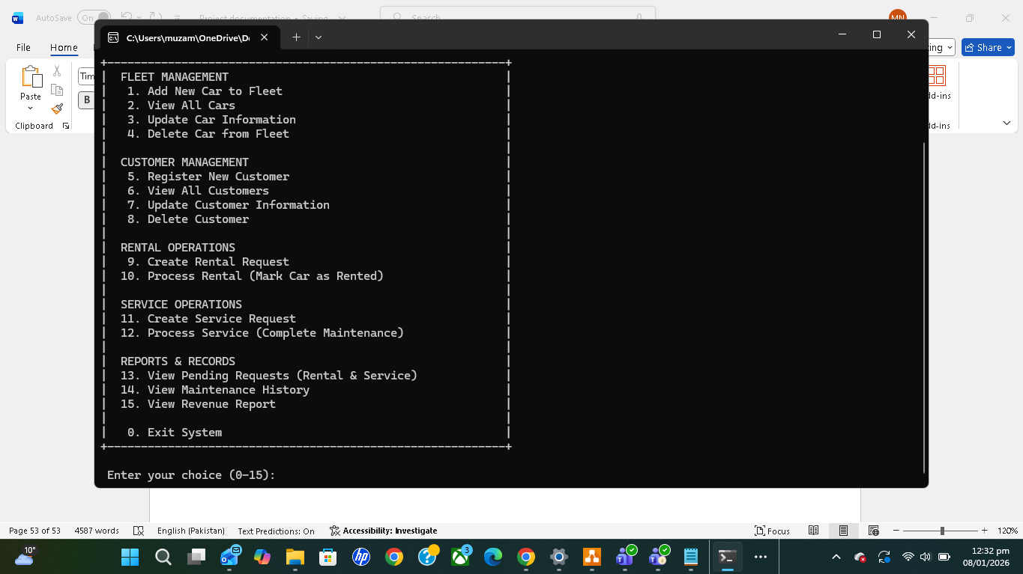
Sub menus
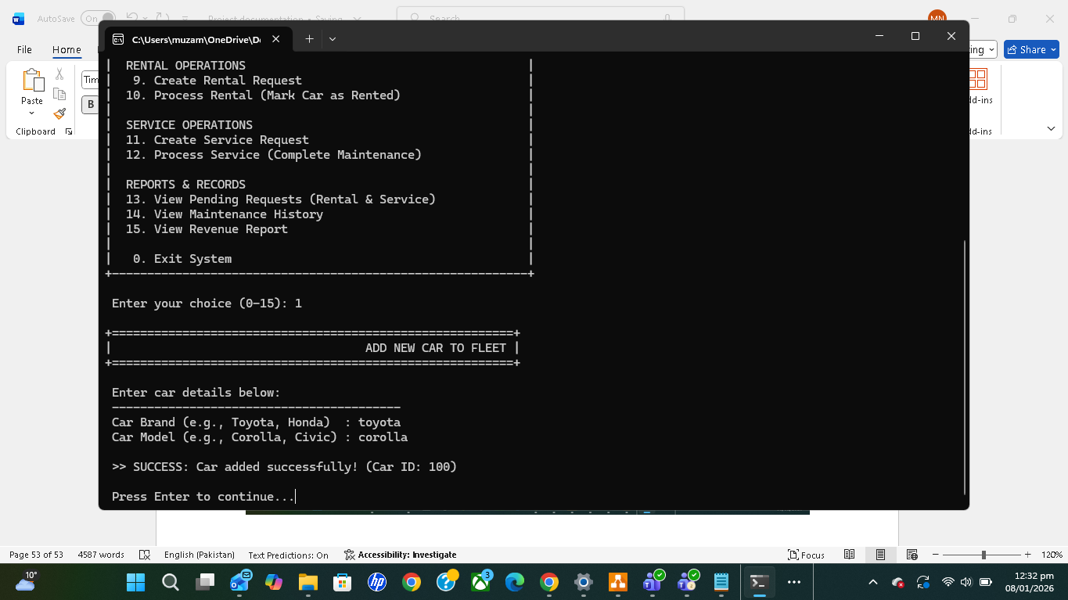
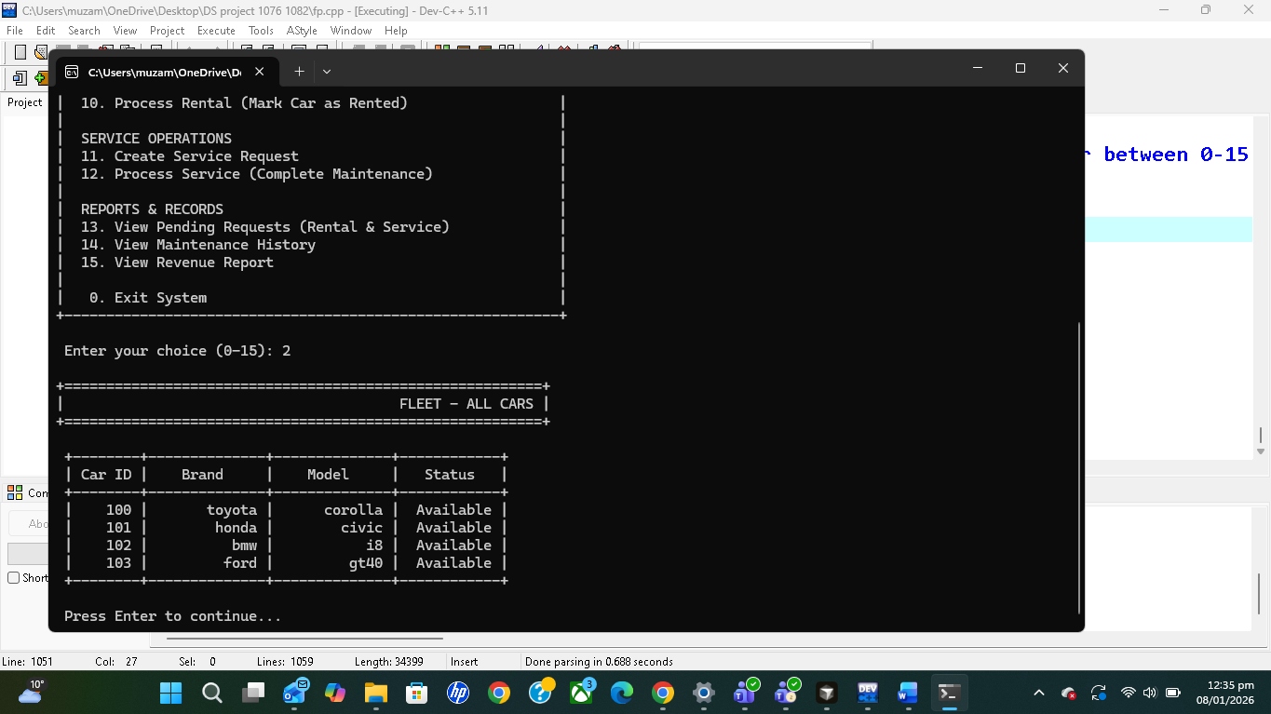
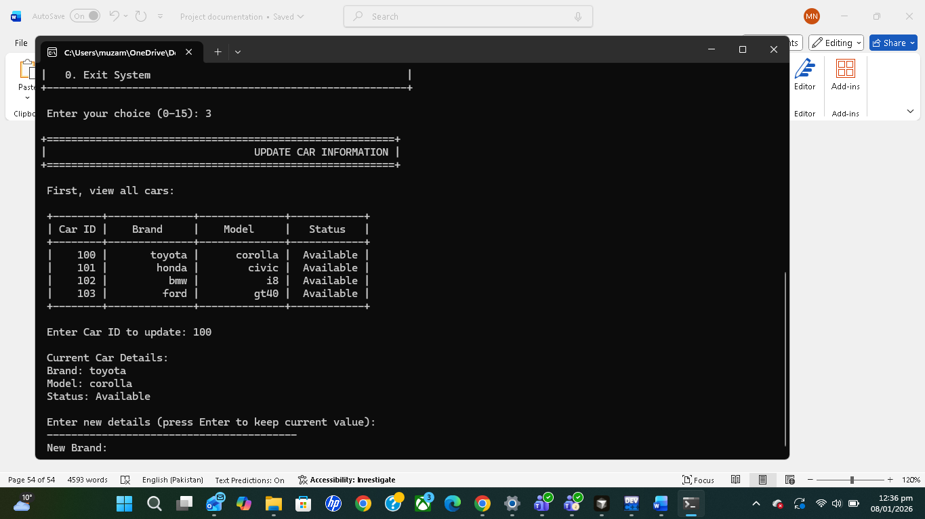
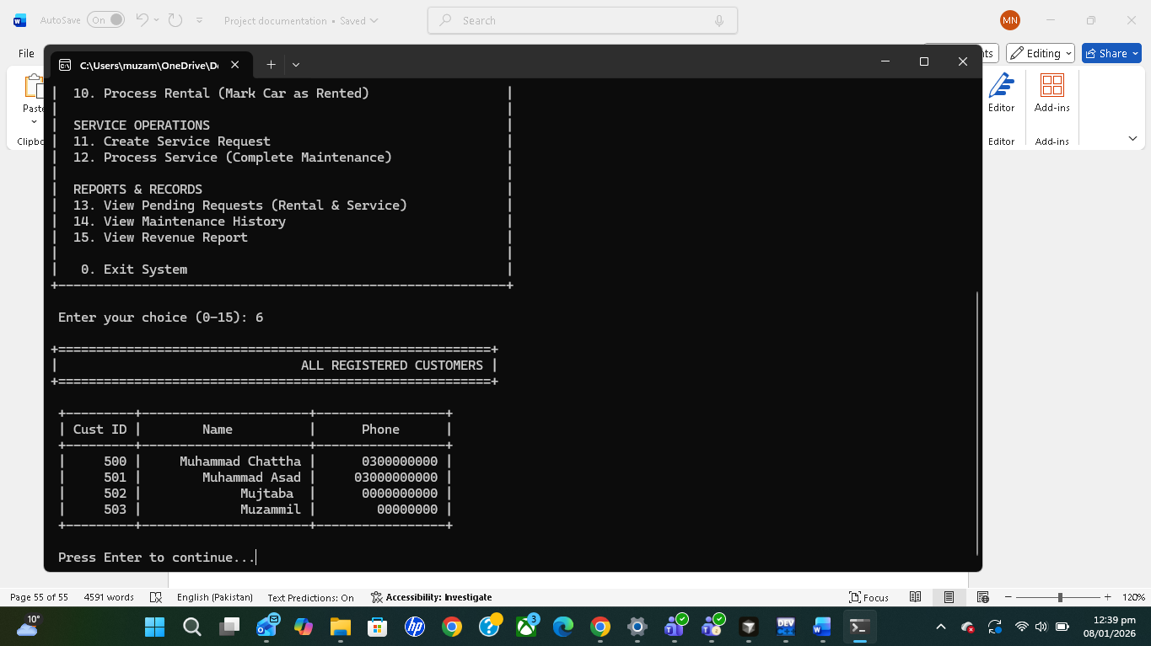
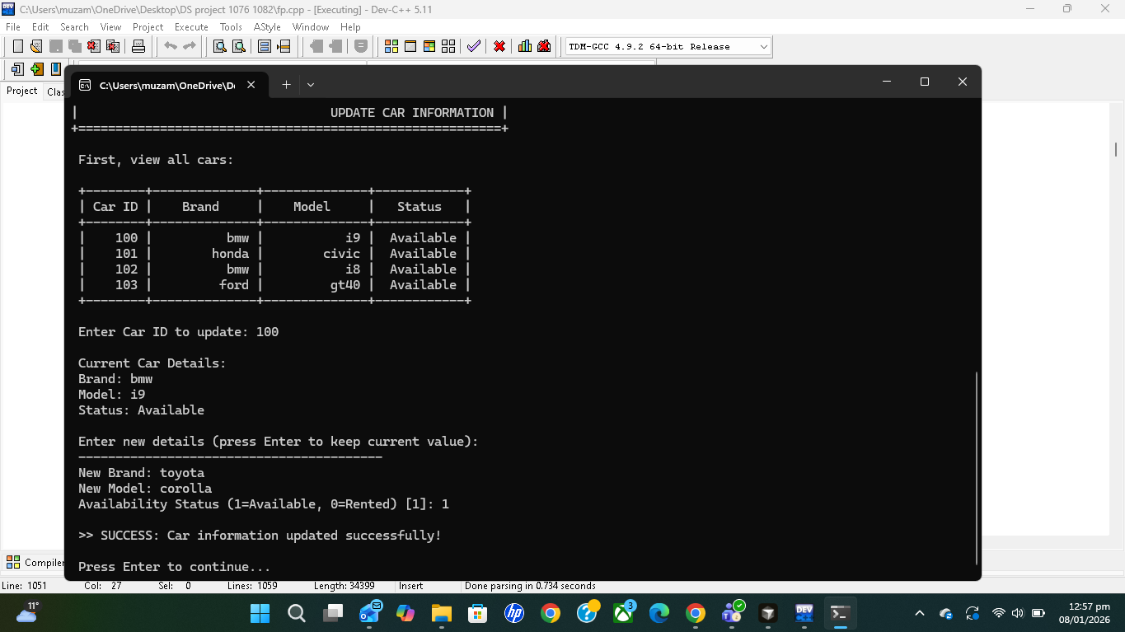
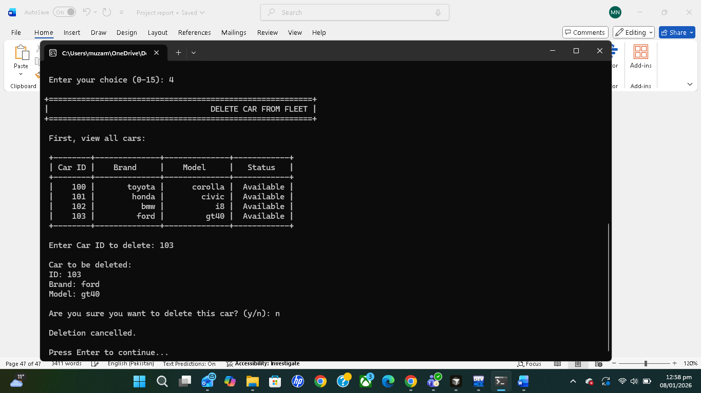
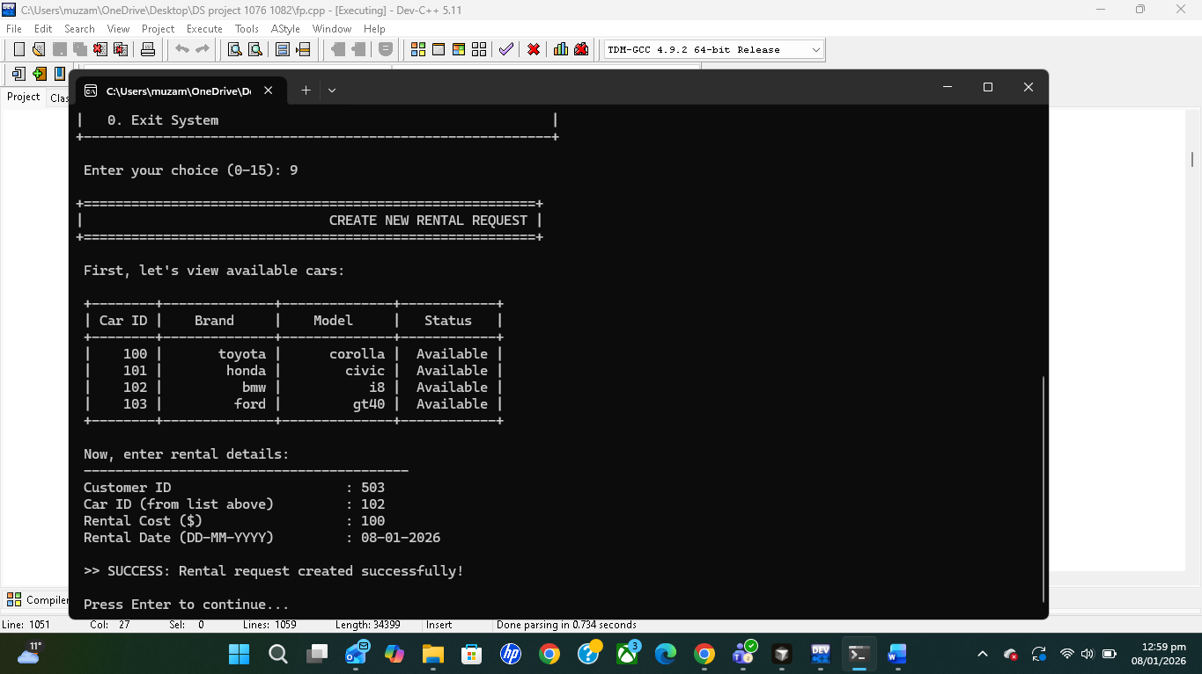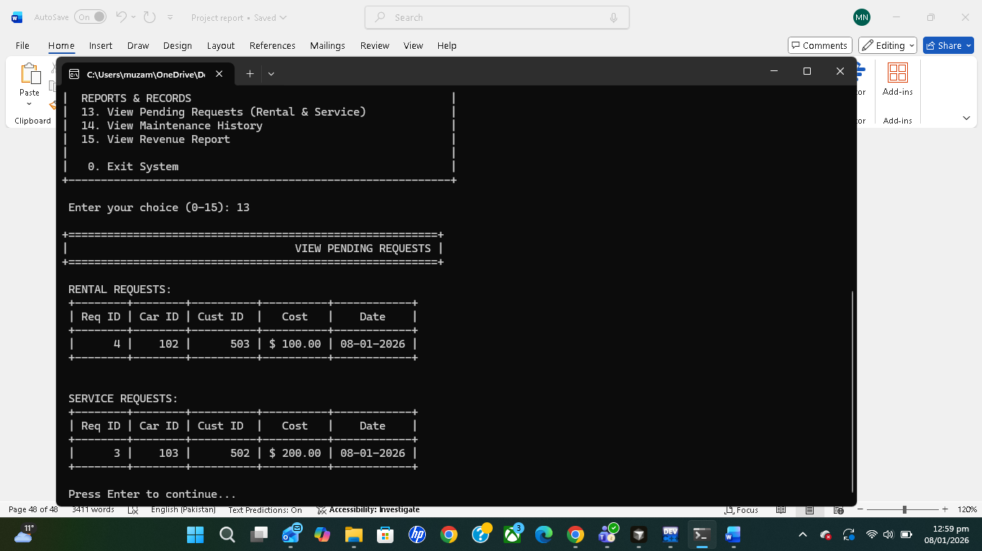
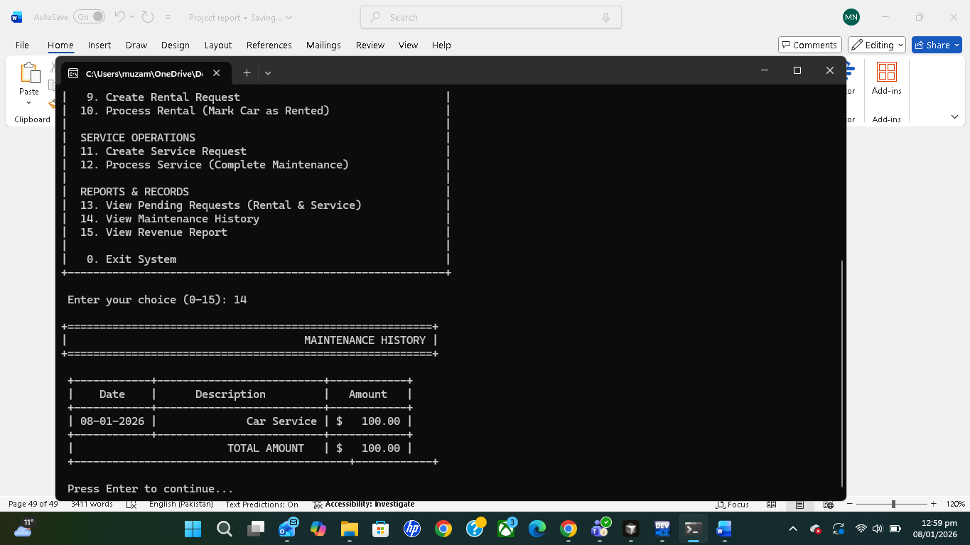
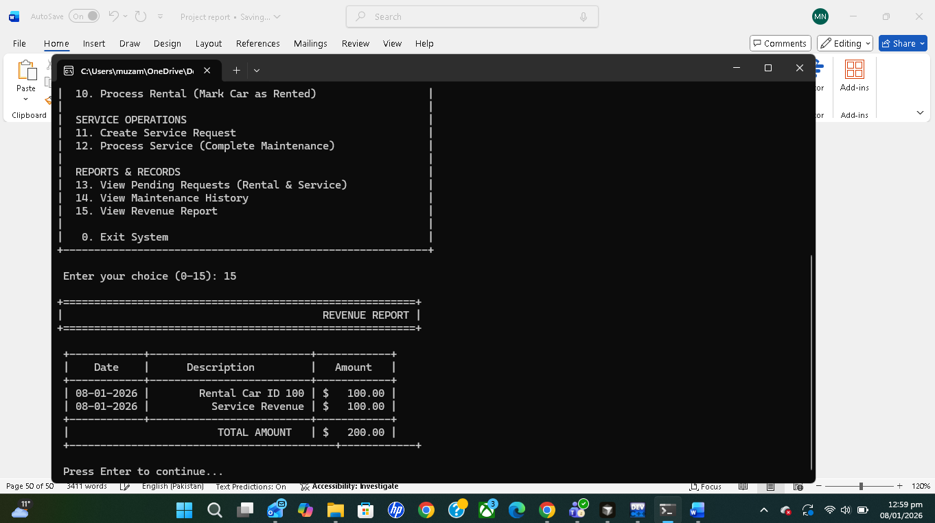
Exiting
